# SUY TIM SÁCH Y3

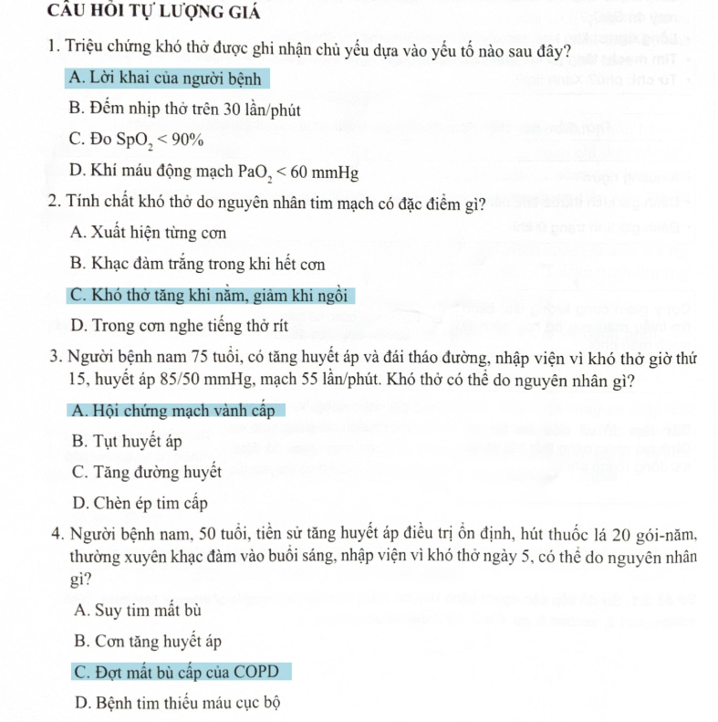

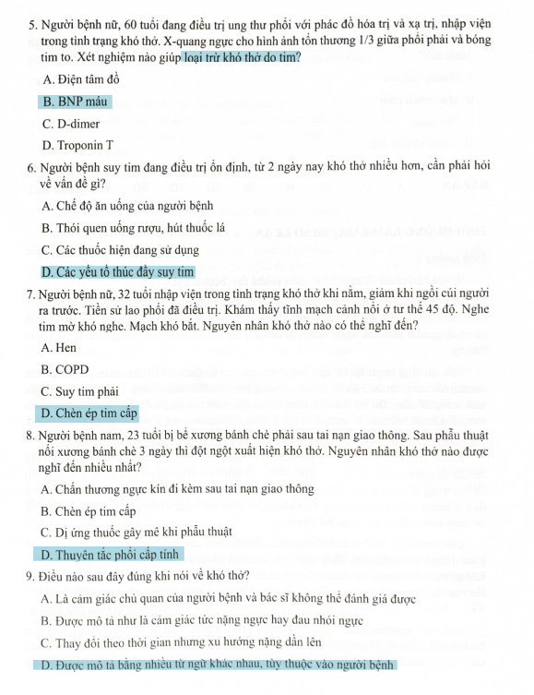 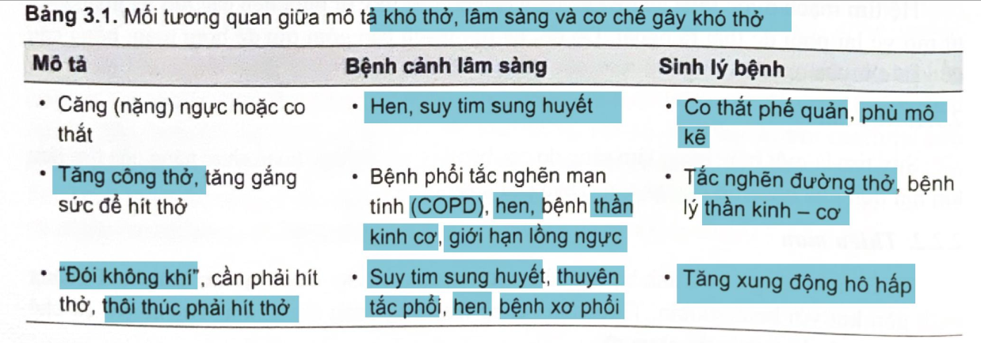 

# SUY TIM SÁCH Y4



